West Hull Ladies
RRC

February Newsletter

Suzanne’s 100th parkrun!!!

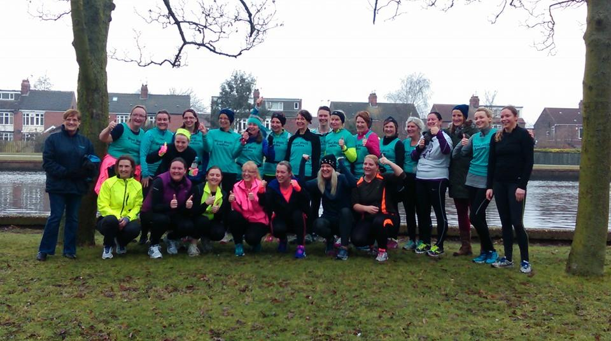
2015 0-5k Ladies 1st parkrun
West Hull Ladies

WEST HULL LADIES RRC COMMITTEE MEETING

Committee Meeting 2nd February 2015

Minutes

Present Maria, Zoe, Jill, Amanda, Linda, Sandra, Rachael L, Andrea

1.Apologies Hayley, Karen, Annette
2. Minutes of previous meeting accepted as accurate record.
3. Matters arising. Rachael confirmed that the gait analysis had been arranged for the 0-5k ladies at Humber Runner. Amanda confirmed the website had been updated to show the change to membership fees. In relation to Presentation evening Linda and Rachael had the event in hand. Jill gave an update on the awards see 5 and Sandra confirmed hoodies and hats had been sourced. Ladies to be informed via email and Facebook on how to order. Also confirmed ladies had been made aware of the courses that are being held - foam rolling 23rd Feb and injury prevention 9th March.
4. AGM this would take place on the 2nd March before the committee meeting. All members to be invited. Action Sandra to put out email asking for nominations/volunteers for the various posts.
5. Presentation evening. A discussion took place around the various awards. The awards would be as last year, 10k, improver, newcomer, member of the year and the True Grit Award. It was also suggested that previous year winner of the trophies may like to present the award. This would be voluntary. Action - Jill to send out email explaining the True Grit Award and ask for nominations - and for member of the year. Jill to work with another member to work out recipients of other awards. Jill + 1 to purchase trophies. Karen S to provide Jill with up to date list of members.
6. Amanda gave an update on the 0-5k training programme and stated how well the ladies were doing. A discussion took place on whether to run the course annually or bi- annually. Bi annually appeared to be the favoured option. The 0-5k ladies were to be running the Park Run on the 14th February. Action Andrea to send out email explaining how to register for the Park Run.
7. Rachael updated the Committee that as yet the new owners do not seem to have any interest in arranging a meeting to discuss rent etc. This was a meeting that we want to take place and will be discussed at a later date.

Ferriby 10 – Linda 25th January

A cold morning but at least it was dry and not very windy. Met up with our Amanda in the car park, she was having a little break from her long cycle ride with some fella’s. It was lovely to get a pre-race hug and good wishes before the start, thank you Amanda. Earlier start than last year but a lot more people taking part. There were quite a lot of us WHL taking part too, I think seven in total (hope I haven’t miscounted)!
I couldn’t find any of our ladies at the start, turns out they had parked at the school and I’d managed to park up near the mill at the start/finish area. So I got myself settled in and before long we were off. Now this run is hilly for the first five miles, not many ‘downs’ at all so I knuckled down and tried to enjoy it (yeah right)! Sometimes I wonder why oh why I ever enter races, they always make me nervous. Anyway before too long there was the lovely friendly cheer from our wonderful Sandra and she always takes photo’s (remember to smile) although it always looks like I’m grimacing. Then we were at halfway and onto the main road leading to Rowley. I love this bit of the race, it’s all downhill and after lots of hill training with the lovely Amanda I now enjoy running down hills (not so much up though)!
Finally we were turning left into Eppleworth Road, now this bit isn’t much fun (for me anyway), it seems such a long way on a straight road, no hills I know but it does seem to go on forever. Then came mile 9, this is where I was ‘pipped’ by the lovely Rachel Anderson, she seemed to sail past me as though it was just the start of the race. Well done Rachel. Then you turn left at the bottom of Skidby hill, oh boy that really is steep after 9.5 miles of lots of other hills, in fact it’s nearly a mountain. Still only 500 metres to go and finally you see the FINISH. At last my well earned t’shirt.
Met up with Rachel A, and just behind me came Liz, Jill, Jan and Tracy then we went to the top of the hill to wait for our other ladies to come in, loved cheering them in.
On the whole a lovely race, so much better than last year. Think I’m already looking forward to next year!

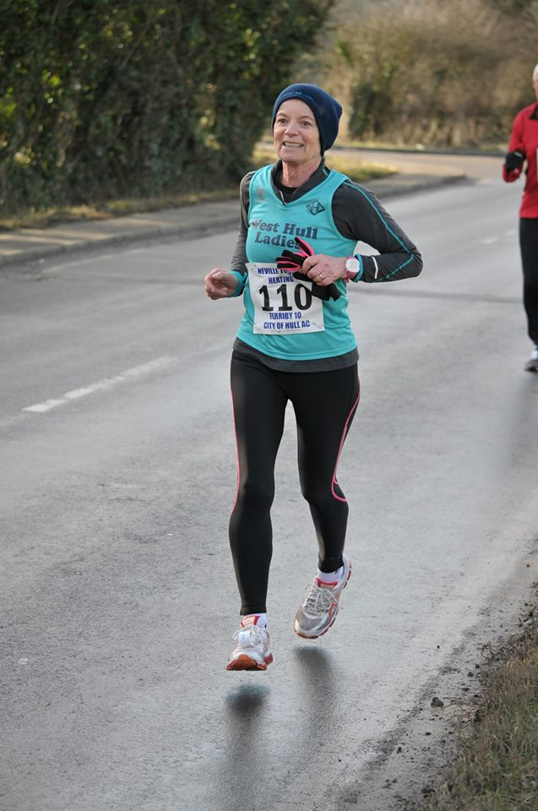

RECIPES

Lauren’s Banana Loaf (Hayley)

My 13yr old daughter makes this every weekend on her own!

140g butter, softened
2 large eggs, beaten
140g self raising flour
1 tsp baking powder
2 very ripe banana’s mashed
50g icing sugar
handful dried banana chips for decoration

- Heat oven to 180C/160C fan/gas 4. Butter 2lb loaf tin and line the base & sides.
- Cream the butter and sugar until light and fluffy, then slowly add the eggs with a little flour. Fold in the remaining flour, baking powder and banana’s. Pour into the tin and bake for about 30 mins until a skewer comes out clean.
- Cool in the tin for 10 mins, then remove to a wire rack.
- Mix the icing sugar with 2-3tsp water to make a runny icing. Drizzle the icing across the top of the cake and decorate with banana chips.

2015 RACE DIARY

Free 5K time trial every Saturday 9am: Hull Parkrun or Peter Pan Parkrun

Fancy something different? For worldwide marathons click here

Date/Time | Event | Fee
March 2015
 | 7th/08:30 | Golden Fleece 16 mile and 27 mile
 | 22nd/10:00 | East Hull 20 Mile
 | 22nd/09:30 | Jane Tomlinson City of Lincoln 10K
April 2015
 | 3rd/10:00 | Bridlington Easter 5 Mile Dash
 | 26th/10:00 | Virgin Money London Marathon
May 2015
 | 3rd/09:00 | North Lincolnshire Half Marathon
 | 10th/11:15 | Beverley 10K
 | 10th/09:30 | Jane Tomlinson Leeds Half Marathon

Please remember to double check dates, times and entry fees Keep checking the website for new races and updates:

NOTE: Club Vests must be worn at any races you enter
under the West Hull Ladies running club name.

West Hull Ladies Road Running Club
Kit Order Form

FORENAME ___________________________________

SURNAME ___________________________________

ORDER - tick what you require, with size Price
- VEST SIZE _____________ £16.00
- LONG SLEEVED SIZE _____________ £18.50
- BEANIE HAT £6.50

DATE Ordered _______________

AMOUNT PAID _______________

Please transfer payments online with your name and marked as ‘Kit to:
Account: 63762742 Sort Code: 20 43 49.
Or cheque payable to ‘West Hull Ladies RRC’, and write your name and ‘Kit’ on the back and give to Club Treasurer Linda Dodsworth, 110 The Stray, South Cave HU15 2AL
Sign on receipt of goods _________________________________
DATE _______________

Please complete this form and email to diazmaria@btinternet.com
Thanks.
Maria Kit Officer

